WEB DESIGN PROJECT – Surveys & Persona

Student Name: Kevin Kiely (solo project)
Student ID: 18186866

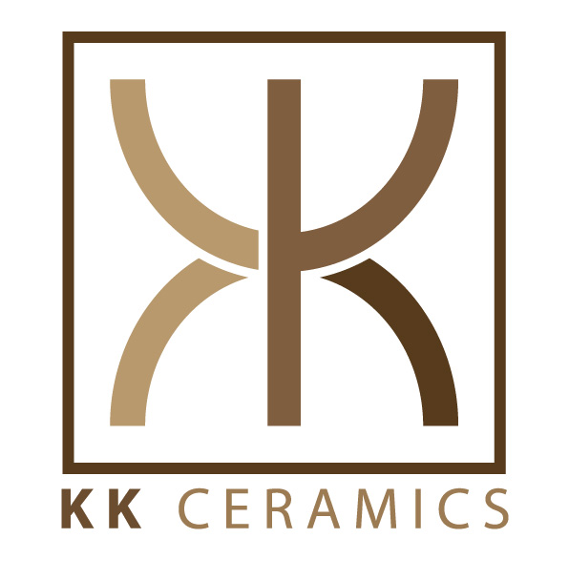

INTRODUCTION

As part of requirements gathering for the design phase of my web design project, I created a list of interview questions in order to generate a user persona to determine how a user would operate within the target market of the website in question. I tried to include as diverse a target group as possible with respect to age, gender and experience with and potential exposure to the subject matter.

The questions asked are as follows:

1 - What is your age range?
2 - Where is your location?
3 - What is your occupation?
4 - Are there any pottery/ceramics businesses in your immediate area?
5 - How do you search for any pottery businesses?
6 - Do you have any experience in working with clay?
7 - Would you be interested in taking beginner/advanced pottery classes?
8 - Do you prefer mass-produced factory ceramics or individual one-off customized pieces?
9 - Do you think one-off customized pottery products are good value?
10 - What do you feel a ceramics business website should display?
11 - To your knowledge, are there any pottery businesses with poor or no online presence?
12 - What social media platforms do you use often?

The following are the 4 surveys that I conducted:
PERSON A - “Keith”

1 - What is your age range? | 40-45
2 - Where is your location? | Limerick City suburbs
3 - What is your occupation? | Graphic Designer
4 - Are there any pottery/ceramics businesses in your immediate area? | There is one approx 10 miles away in Co. Clare that gives classes and is quite popular, there are 2 or 3 other smaller ones in the city area.
5 - How do you search for any pottery businesses? | Google
6 - Do you have any experience in working with clay? | Some basics in Art School 20 years ago but none since then
7 - Would you be interested in taking beginner/advanced pottery classes? | Possibly but depends on work/family commitments, would like a few different time options for classes
8 - Do you prefer mass-produced factory ceramics or individual one-off customized pieces? | Coming from art school background I appreciate custom designs more.
9 - Do you think one-off customized pottery products are good value? | Yes as long as price is reasonably affordable
10 - What do you feel a ceramics business website should display? | Images of the pottery is most important, info about classes also
11 - To your knowledge, are there any pottery businesses with poor or no online presence? | 1 or 2 older businesses I have encountered in other locations in the country seem to have no website or rarely updated facebook pages
12 - What social media platforms do you use often? | Facebook

PERSON B - “Amy”

1 - What is your age range? | 20-25
2 - Where is your location? | Pallaskenry, Co. Limerick
3 - What is your occupation? | Shop Assistant
4 - Are there any pottery/ceramics businesses in your immediate area? | Not in the immediate area, closest that I know of would be in Limerick City approx 12 miles away
5 - How do you search for any pottery businesses? | Google, Facebook search.
6 - Do you have any experience in working with clay? | None apart from briefly in primary school
7 - Would you be interested in taking beginner/advanced pottery classes? | Yes if there was a pottery business close-by
8 - Do you prefer mass-produced factory ceramics or individual one-off customized pieces? | No preference, I like both
9 - Do you think one-off customized pottery products are good value? | Good value if the piece can be used for something practical
10 - What do you feel a ceramics business website should display? | Showing the products is crucial
11 - To your knowledge, are there any pottery businesses with poor or no online presence? | The few businesses that I know of seem to have their own websites
12 - What social media platforms do you use often? | Facebook, Twitter, Instagram, Snapchat

PERSON C - “Kathy”

1 - What is your age range? | 55-60
2 - Where is your location? | Templeglantine, Co Limerick
3 - What is your occupation? | Home care assistant
4 - Are there any pottery/ceramics businesses in your immediate area? | Not within 20-30 mile radius
5 - How do you search for any pottery businesses? | Google or Bing search
6 - Do you have any experience in working with clay? | None
7 - Would you be interested in taking beginner/advanced pottery classes? | Yes but would need to be acceptable commuting distance
8 - Do you prefer mass-produced factory ceramics or individual one-off customized pieces? | I admire both but prefer one-off pieces
9 - Do you think one-off customized pottery products are good value? | Sometimes yes sometimes no
10 - What do you feel a ceramics business website should display? | Most important is to see the products clearly and their prices, or any pricing info for customized one-off pieces. A timetable of classes and costs involved would also be helpful.
11 - To your knowledge, are there any pottery businesses with poor or no online presence? | One or 2 websites I have seen are poorly updated/outdated
12 - What social media platforms do you use often? | Facebook but only rarely

PERSON D - “Ciaran”

1 - What is your age range? | 30-35
2 - Where is your location? | Loughlinstown, Co Dublin
3 - What is your occupation? | AutoCAD Technician
4 - Are there any pottery/ceramics businesses in your immediate area? | Quiet a few small to mid-size pottery businesses in the greater Dublin region
5 - How do you search for any pottery businesses? | Google or check local listings, supermarket message boards etc
6 - Do you have any experience in working with clay? | None
7 - Would you be interested in taking beginner/advanced pottery classes? | Yes beginner classes appeal to me
8 - Do you prefer mass-produced factory ceramics or individual one-off customized pieces? | No preference
9 - Do you think one-off customized pottery products are good value? | Yes if made properly and useful or good artistic qualities
10 - What do you feel a ceramics business website should display? | Many images of products, good navigation to get around site, easily found contact details for the business.
11 - To your knowledge, are there any pottery businesses with poor or no online presence? | Some smaller businesses could be marketed a little better, hard to find on google.
12 - What social media platforms do you use often? | Facebook, Twitter.

Using all this gathered information, I constructed a persona which best represents the target audience user who will use the website:

KK CERAMICS CUSTOMER PERSONA

 | Name: Jane Doe  DEMOGRAPHICS  Gender: Female  Age: 34  Location: Ennis, County Clare, IRELAND  Occupation: Graphic Designer (Part time)  Qualification: First Class Honours Degree in Product Design  Status: Married, 2 children
USER EXPERIENCE ENVIRONMENT

Feels very comfortable using a laptop and PC as she uses these during normal work day. Frequent user of smartphones both in and out of the workplace, to google information and check up on social media applications.

GOALS FOR USING POTTERY/CERAMICS WEBSITE

- Eager to learn new skills; a more hands-on approach to design rather than designing on paper or on screen.
- Comfortable researching the subject matter, also interested in purchasing pottery pieces as well as taking classes in the area.
- Feels good about a background in design will help and compliment taking of any ceramic design classes.
- Works part time so has enough free time to devote to learning a new skill such as pottery.
- Main concerns are finding a pottery business in the general area, close enough to visit but also to attend classes in future.

QUOTATIONS

“Looking forward to getting my hands dirty!”

